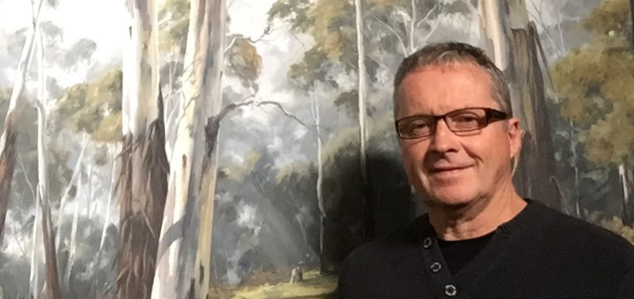
Garry Pettitt (b.1959)

Garry was born and educated in Lithgow. He began painting at the age of ten and is self-taught. Garry left his career as an electrician in 1994 to pursue his art.

Since turning professional, his success has escalated, winning many awards. In 2008 and 2011, Garry won the prestigious Royal Agricultural Society Art Award for the best landscape painted in a “Traditional” style at the Sydney Royal Easter Show. In 2011 he was awarded First Prize in the figurative section and that portrait also won Best Exhibit across all art sections and an Award of Excellence.
He was awarded People’s Choice at Portland Art Show 2010, and was Guest Artist at Portland Art Show in 2012.
He has had six major solo exhibitions, all of which have been a huge success.
Garry captures the atmosphere of Australia in his oil paintings, whether they are of the landscape, seascape, a streetscene or its’ people, through his attention to light, colour and detail.
Garry’s paintings are in collections around Australia, as well as USA, Singapore and Belgium. Garry resides in South Bowenfels, a suburb of his home town of Lithgow, in the Blue Mountains, N.S.W., Australia.

Garry’s works can be viewed on
www.garrypettitt.com
www.facebook.com/garrypettittfineart

